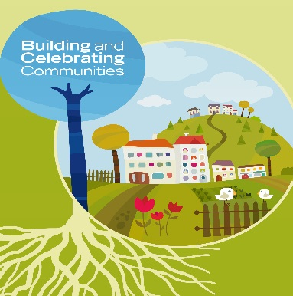
BUILDING AND CELEBRATING COMMUNITIES: TOUCHING BASE PROFORMA
Celebrations, challenges and connections

Please fill in the respective sections providing as much detail as possible. If you need assistance or advice on any area of this process, please do not hesitate to contact Euan Duguid, Lead Communication Officer by email or phoning 07917041853

Submitted by: Name, organisation and contact details including email and telephone number.
Celebrations: What projects or initiatives have you got off the ground since the BCC events last summer? What are you continuing to build? What results are you seeing and what difference are your efforts making?
Challenges: What challenges and obstacles are you coming up against in your endeavours? How are you negotiating them? If these challenges haven’t been overcome, what would help you?
Connections: Who’s driving your efforts? What connections have you made? What networks are you finding helpful, what connections would make your work easier?
Any other comments or reflections?

